Team Number: 4
Team Member Names: Yanhao Liu, Meredith McCalmont, Irving Zhang

- Story
It was a busy afternoon at the campus cafe. Anna, a student worker, rushed to prepare coffee orders while customers waited in line. For each drink, she needed to measured coffee, milk and water in specific ratios. A small mistake could change the taste and switching containers while watching volume markings required constant attention. Imagine if she could simply select a recipe[1] and let the system handle the rest. Our proposed desktop-scale automated mixing system allows the users to choose a desired ratio through a simple interface. The system then dispenses controlled amounts of liquid ingredients [2], mixes them in a chamber [3], and provides clear visual feedback when the process is complete [1]. This demonstration prototype shows how mechatronics can reduce human error, improve repeatability and simplify routine preparation.

- Updated table of mechatronics elements from your proposal (address all issues that were pointed out in first version; do not remove or mark comments as resolved; track changes if there are any, otherwise leave it unchanged). [DONE] Irving
See task list below
- A sketch or basic CAD model of the system so that it can be discussed during the Check-in. [DONE] Meredith
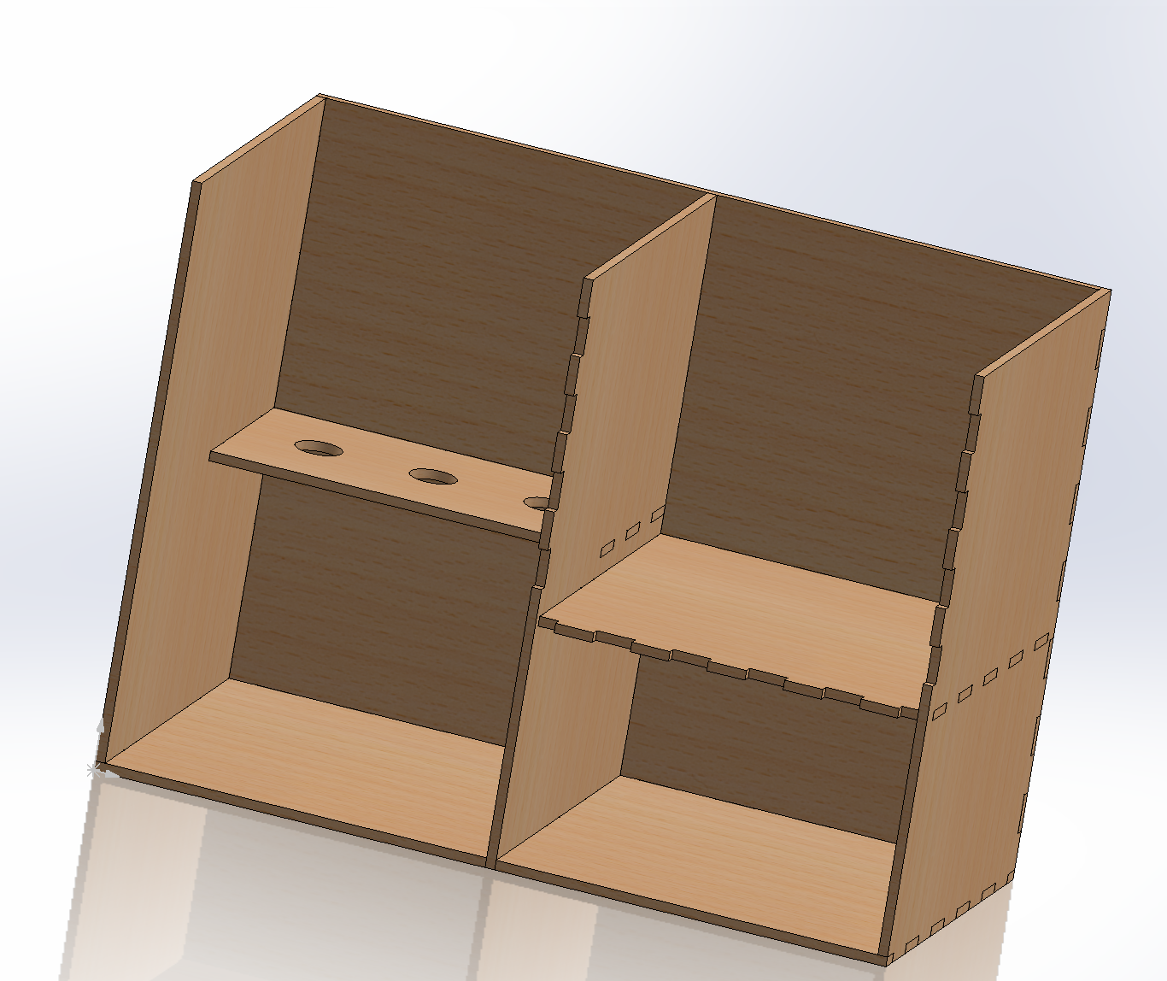
Liquid Dispenser SolidWorks section viewing of inside of liquid compartments and shell to hold wiring and motor.
- A flowchart that describes the operation of your system (think of this as the basis for pseudo-code for your system – it should describe the tasks being done by the microcontroller). Below are examples from prior submissions – one for an automated system for heating shrink-fit tooling in a machine shop, one for an automatic plant watering system, and one for an automatic coffee maker. Your flowchart must use these types of standard flowchart shapes. If your code has an interrupt routine, show it as a separate flowchart and be sure to indicate what action triggers it.-Yanhao[DONE]
https://www.canva.com/design/DAHEECWxWkY/CAYTjzL4sgDCszIu1u1KdA/view?utm_content=DAHEECWxWkY&utm_campaign=designshare&utm_medium=link2&utm_source=uniquelinks&utlId=h26113f0e44

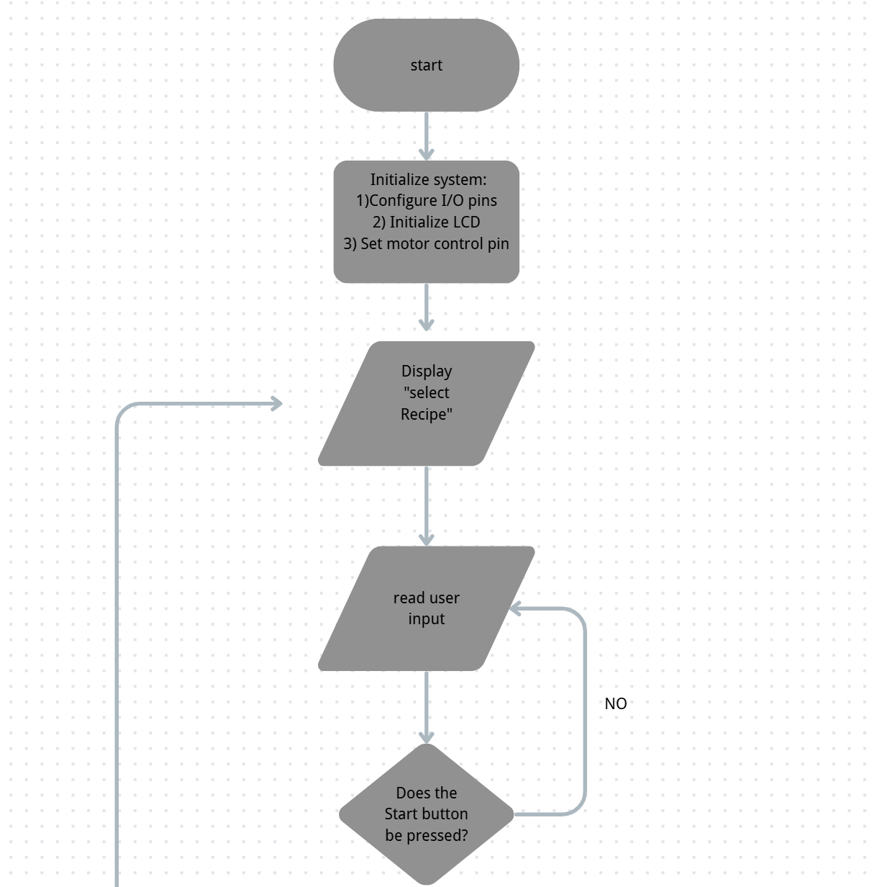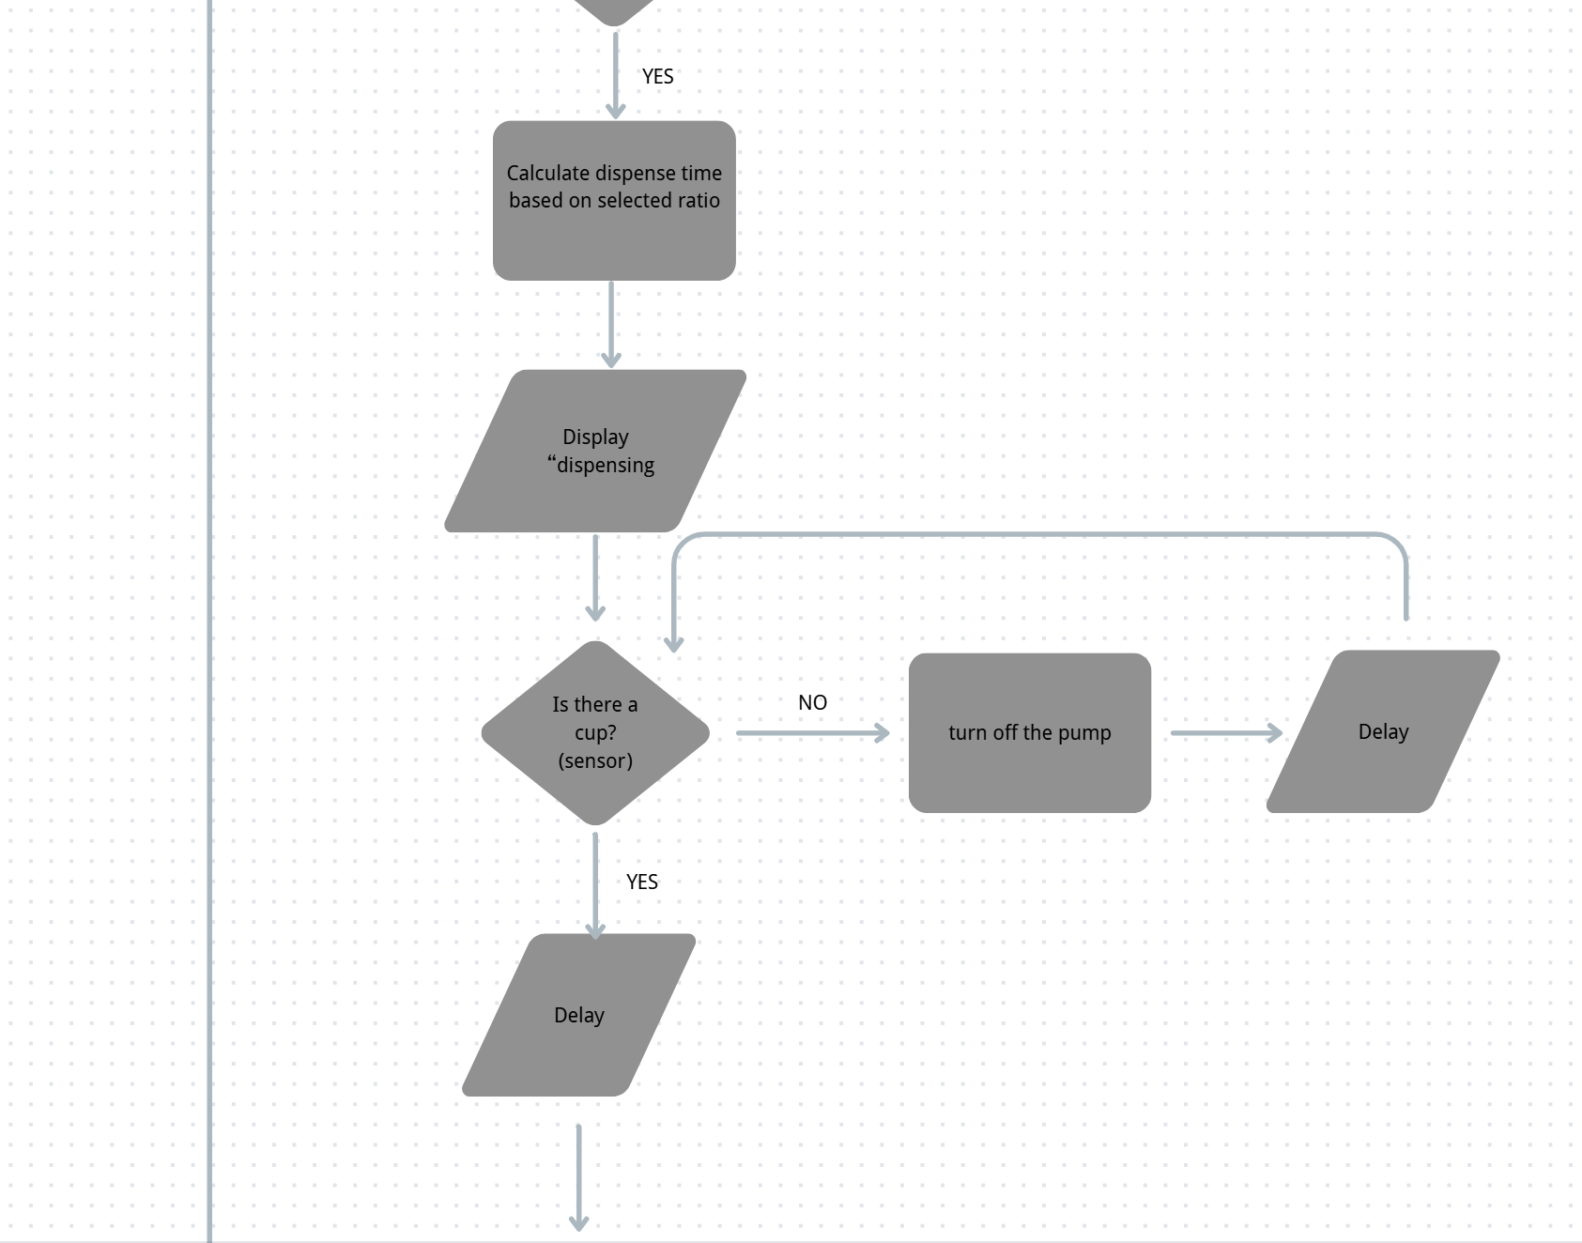
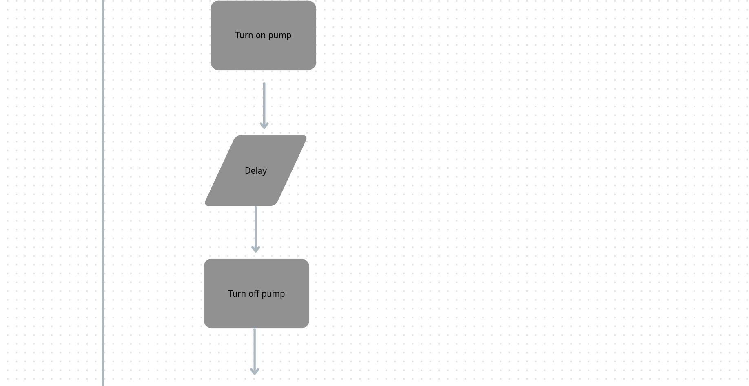

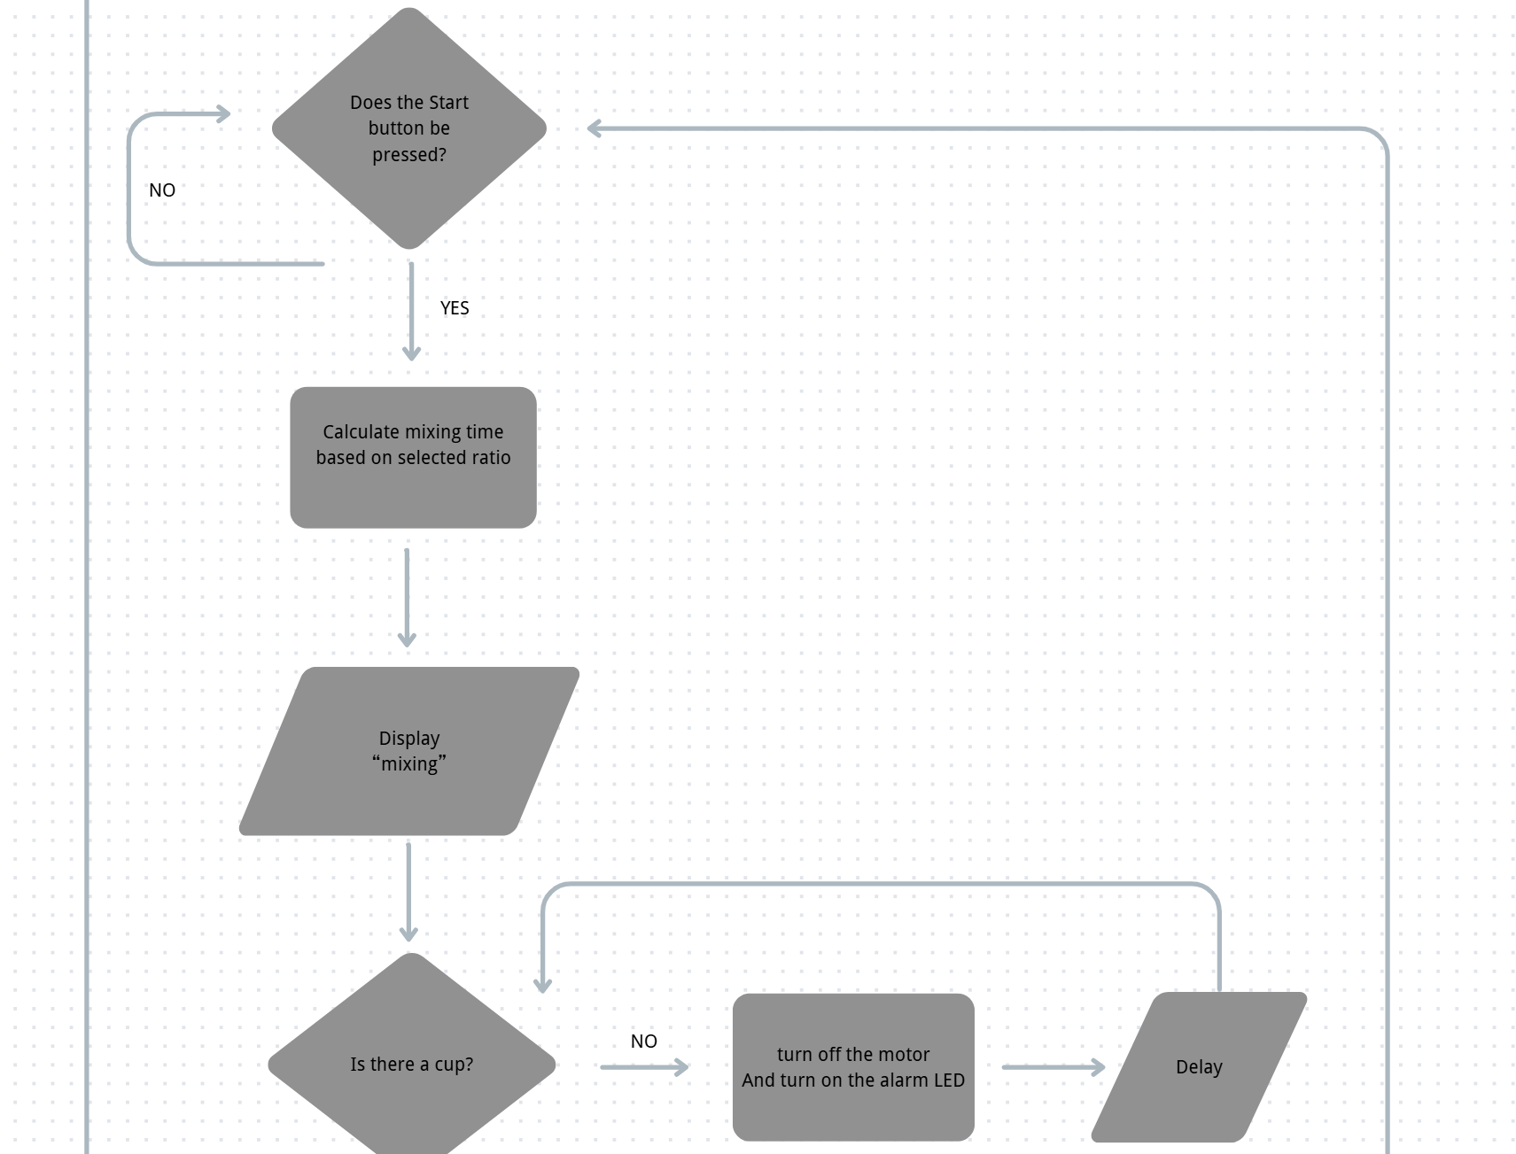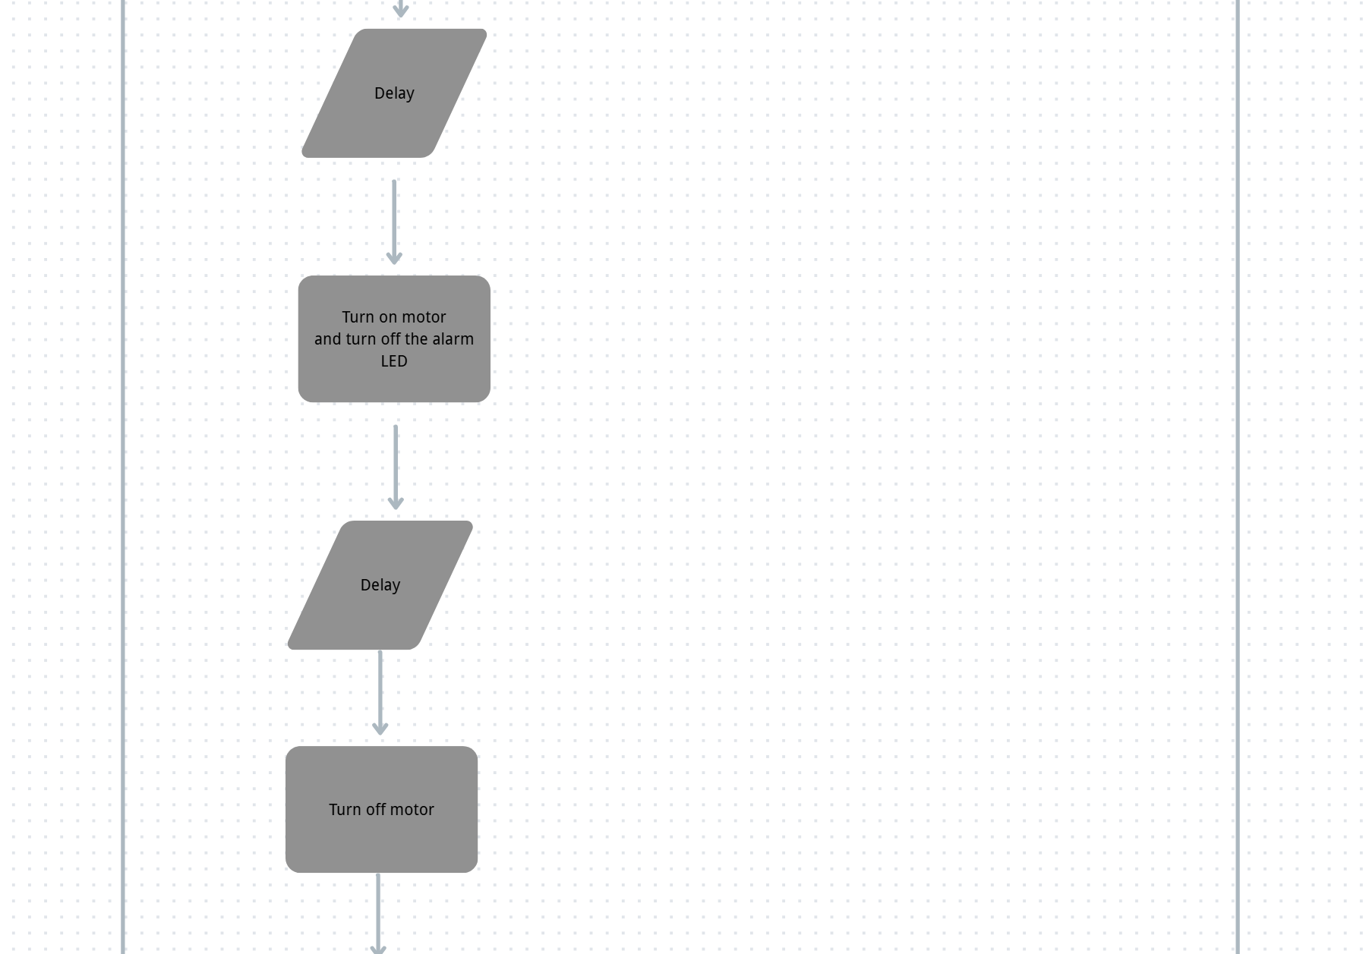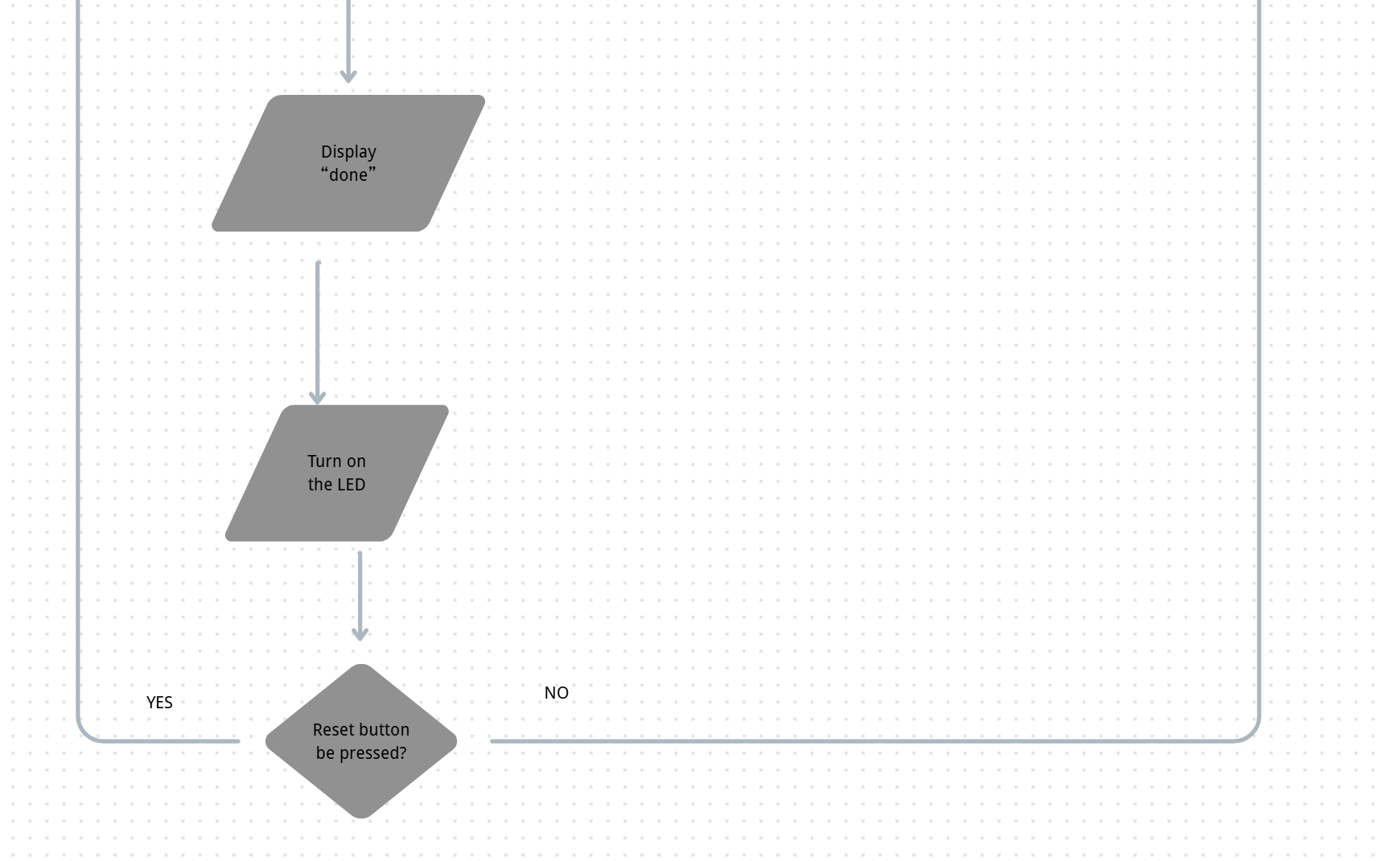
- A list that indicates which team members will be responsible for what parts of the system. This may be done with a Gantt chart or just a list. Each team member must take part in software and hardware development. Address all aspects of the project, from start to finish
Feature | Description | Mechatronics Element | Effort | Assigned to
Feature 1  Recipe selection | The input interface allows user to select a predefined recipe or mixing ratio, to define how  liquids will be dispensed and mixed. The selection cycles from a sequence of predefined recipe list. | Pushdown button switch (binary input) | 5 | Meredith
 | This LCD display provides real-time system feedback by showing machine states (waiting, dispensing, mixing, complete, fault) and the selected recipe name to improve usability and clarity. | LCD | 20 | Irving
 | The button allows users to confirm the recipe selection or cancel/quit the workflow after confirmation. | Pushdown button switch (binary input) | 5 | Irving
Feature 2  Automated liquid dispensing | The sensor detects whether there’s a cup present in the working area and if it’s safe to dispense the liquid. | Force sensor | 10 | Yanhao
 | This timing control ensures the motor dispenses repeatable and consistent liquid volumes. | Delay / timing control | 5 | Yanhao
 | This motor-driven pump dispenses liquid when commanded by the selected recipe. | Solenoid | 15 | Meredith
 |  | Solenoid | 10 | Meredith
 |  | Solenoid | 5 | Meredith
 | If the cup is removed during dispensing, an interrupt-based safety stop immediately shuts off the pump and triggers an alarm indicator. | Interrupt | 5 | Yanhao
 | This alarm LED indicates a fault condition (cup removed mid-process) so the user knows to reset. | LED | 5 | Meredith
Feature 3  Mixing process | The motor rotates the stir bar to mix well the liquid. | motor | 30 | Yanhao
 |  | Total
 |  | Scale Factor | 115

- Show an analysis of how at least one motor and power electronics were selected for the project:
  - explain with words and images which motor is being analyzed (where is it in your system, what it does, show a schematic of the portion of the system being moved by the motor)
The motor we chose is the Pololu 75:1 Micro Metal Gearmotor HP 6V with Extended Motor Shaft.
This motor offers torque and speed within the linear bounds of our calculated graph of stall torque and no speed. Further, the motor offers a torque low enough to simulate the mixing motion of a human. The torque was checked with the worst-case scenario for power as well and passed.
The extended shaft itself will offer easy attachment for mixing tool as other motors offered much tinier shafts compared to the Pololu 75:1 1 Micro Metal Gearmotor HP 6V.

  - show estimates for required speed and torque and explain how those estimates were made. One or more free body diagrams and accompanying force or torque equations must be shown. Show the derivation for required torque and speed in variable form and then show the final calculations in numeric form. Do not attempt to show this by way of Matlab code or a spreadsheet.
Motor Analysis

- FBD
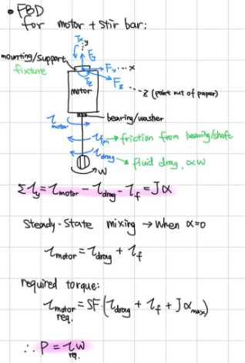
Figure 1: free-body diagram of motor and stir bar
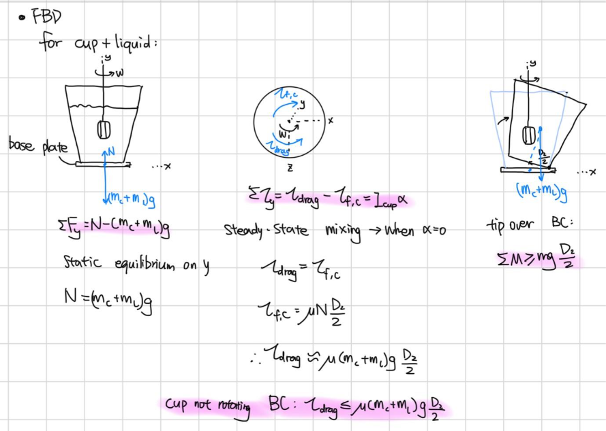
Figure 2: free-body diagram of cup and liquid
- Estimate dimensions, parameters, and assumptions
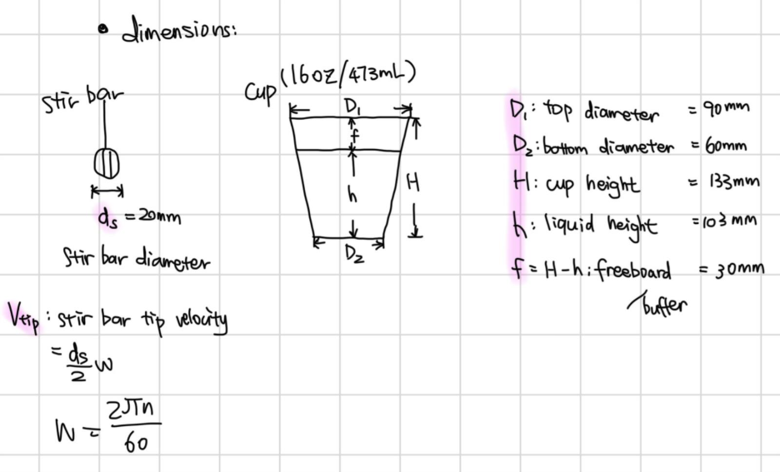Figure 3: dimension schematics of stir bar and cup

- Fill up 80% volume of the cup, liquid volume is fixed to be 16oz/473ml. (h = 0.8H)
- Paper/plastic cup mass m_{c} = 20g
- Average liquid density ρ = 1050kg/m³
- Mixing time t = 15s
- diameter of stir bar d_{s} = 20mm
- Height of stir bar h_{s} = 10mm
- linear speed of stir bar tip $v_{tip}$ = 1m/s

- Speed range
- Too low: Produce weak bulk circulation, longer mixing time
- Too high: Cup tipping over, spilling/splashing, creating too much foam
Thus, set our estimate mixing time to be 15s, and determine our lower speed range by:
$$Re=\frac{ρnd_{s}^{2}}{μ}$$

Where:
Re = Reynolds number
𝜌 = density of liquid [kg/m³]
n = rotational speed [rpm]
μ = dynamic viscosity ≈ 0.001 Pa · s for water-based liquid

If we set lower rotational speed to be n = 300 rpm,
$$Re=\frac{ρnd_{s}^{2}}{μ}=\frac{\left(1050\right)\left(300\right){\left(0.02\right)}^{2}}{0.001}≈2100$$

For stirred tank systems, Re > 2000 typically indicates turbulent or transitional mixing, which enhances bulk circulation.

To determine the higher range of rotational speed, we use tip speed and splash boundary conditions, set $v_{tip}$to be 1m/s.
$$ω=\frac{2πn}{60}$$
ω = angular speed [rad/s]
n = rotational speed [rpm]
$$v_{tip}=\frac{d_{s}}{2ω}=\frac{d_{s}}{2}\frac{\left(2πn\right)}{60}$$

$$n=\frac{\left(2v_{tip}\right)}{d_{s}}\left(\frac{60}{2π}\right)=\frac{2\left(1\right)}{\frac{20}{1000}}∙\left(\frac{60}{2π}\right)≈955rpm$$

To provide margin/buffer for freeboard variation and vibration during demonstration, the operating maximum speed was set to 800 rpm.
Thus, the speed range of the motor would be 300-800 rpm.
- Torque and power
- Liquid viscosity range - τdrag
- mixing waiting time
Assumptions: mixing is 15s at 300rpm, to determine drag torque applied on stir bar by liquid, using dynamic pressure equation:
$$q=\frac{1}{2}ρv_{tip}^{2}=\frac{1}{2}ρ{\left(\frac{d_{s}}{2}\frac{2πn}{60}\right)}^{2}=\frac{1}{2}\left(1050\right){\left(\frac{0.02}{2}\frac{2π\left(300\right)}{60}\right)}^{2}≈51.48pa$$
$$τ_{drag}=FL=qA\frac{d_{s}}{2}=q\left(d_{s}h_{s}\right)\frac{d_{s}}{2}=\left(51.48\right)\left(0.02\right)\left(0.01\right)\left(\frac{0.02}{2}\right)≈0.00010296N∙m$$
The dynamic pressure method underestimates drag because it neglects vortex formation
and bulk circulation. Therefore, a conservative engineering estimate safety factor of 3 was
selected based on similar small beverage mixers.
$$τ_{drag}=3⋅\left(0.00010296\right)≈0.000286N∙m$$

In small DC motor systems with light radial loading, bearing friction torque is typically on the order of 10–50% of applied load torque. A mid-range value estimate was selected as a conservative design assumption.
$$τ_{f,m}≈0.01N∙m$$

As motor runs, rotational speed gradually increases by constant angular acceleration until steady-mixing state and reach defined rpm. Let’s set accelerating/deaccelerating time to be 2s each, we got our angular velocity vs time plot and acceleration vs time plot:
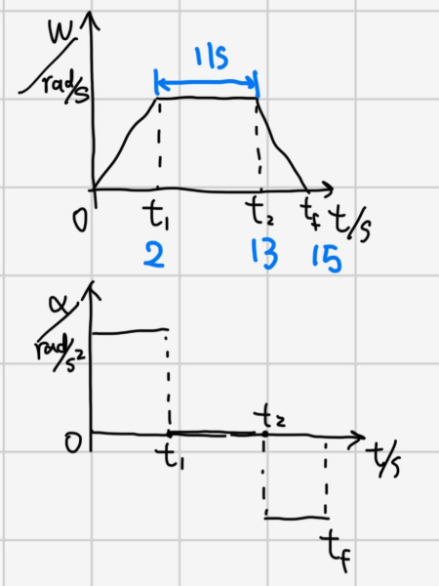
Figure 4: angular velocity vs time plot and acceleration vs time plot

To find maximum acceleration,
$α_{max}=\frac{Δω}{t_{1}}=\frac{\left(\frac{2πn}{60}-0\right)}{2}=\frac{2π\left(300\right)}{60\left(2\right)}≈15.708rad/s^{2}$

$$J=J_{shaft}+J_{stirbar}$$

Let’s assume that stir bar is solid disk, shaft is slender rod, bearings is cylinder.
Shaft dimensions: length l = 80mm, diameter d = 3mm, density of stainless steel
ρ = 8000kg/m³
$$m=ρV=ρπ{\left(\frac{d}{2}\right)}^{2}l=\left(8000\right)π{\left(\frac{0.003}{2}\right)}^{2}0.08=4.5g$$
$$J_{shaft}=\frac{1}{2}m{\left(\frac{d}{2}\right)}^{2}=\frac{1}{2}\left(4.5\right)\left(0.001\right){\left(\frac{0.003}{2}\right)}^{2}≈5×{10}^{-9}kg∙m^{2}$$
Stir bar mass m = 3g:
$$J_{stirbar}=\frac{1}{2}m{\left(\frac{d}{2}\right)}^{2}=\frac{1}{2}\left(3\right)\left(0.001\right){\left(\frac{0.02}{2}\right)}^{2}≈1.5×{10}^{-7}kg∙m^{2}$$

Thus,
$$J=J_{shaft}+J_{stirbar}=5×{10}^{-9}+1.5×{10}^{-7}≈1.6×{10}^{-7}kg∙m^{2}$$
$$τ_{motor}=SF\left(τ_{drag}+τ_{f,m}+Jα\right)=2\left(0.000286+0.01+\left(1.6×{10}^{-7}\right)\left(15.708\right)\right)≈0.01029N∙m$$
$P=τ_{motor}∙ω=\left(0.01029\right)\left(\frac{2π\left(300\right)}{60}\right)=0.64629$

  - Show a torque-speed diagram for your chosen motor and mark the worst-case operating point that was found in your analysis. -[DONE]Yanhao
Torque-Speed Diagram and Worst-Case Operating Point.docx
The motor we choose is 75:1 Micro Metal Gearmotor HP 6V with Extended Motor Shaff
https://www.pololu.com/product/2215
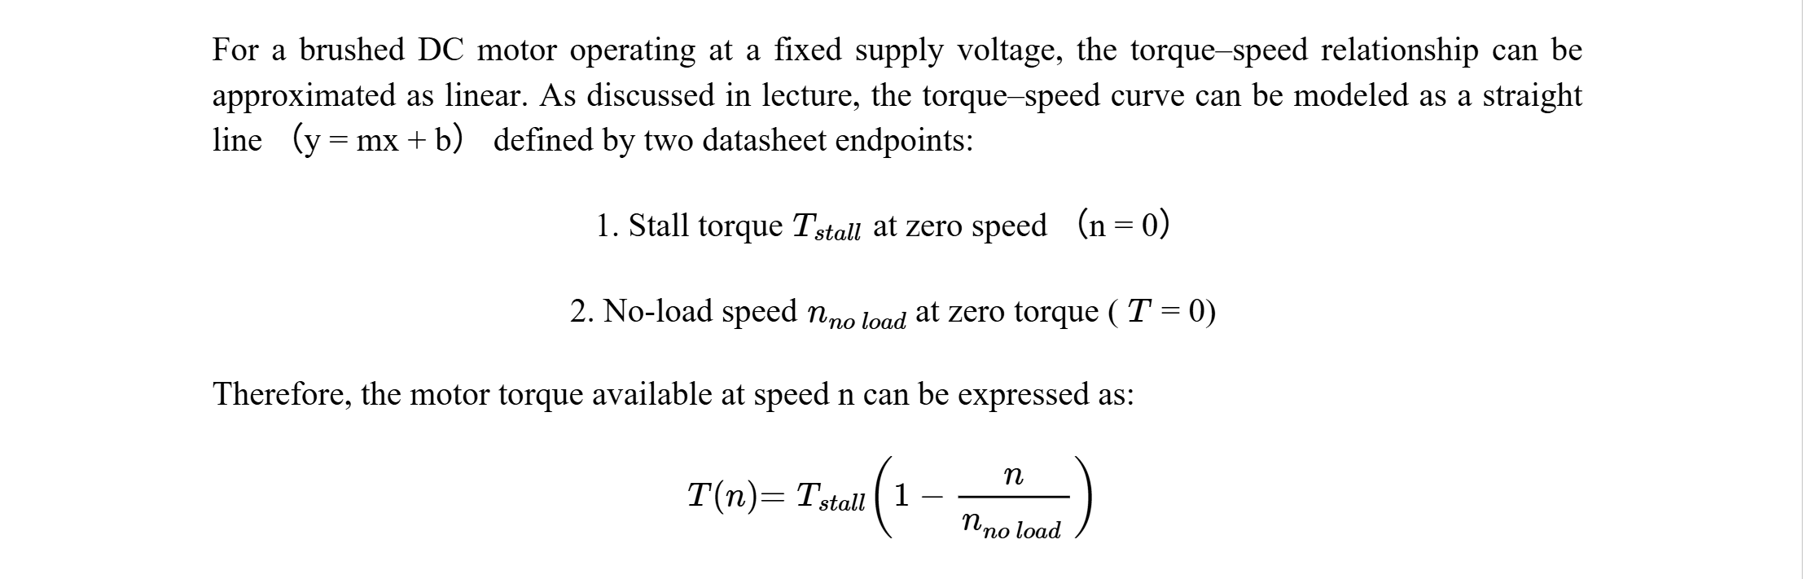

The maximum required operating speed of the mixer is 300 rpm. Since torque demand must still be met at this highest intended operating speed, this point is treated as the worst-case operating condition.
nreq=300 rpm

Treq=0.01029 Nm

This point (300 rpm, 0.02058 Nm) is marked on the diagram as the worst-case operating point. We can see that the worst-case operating point lies below the motor torque-speed curve.

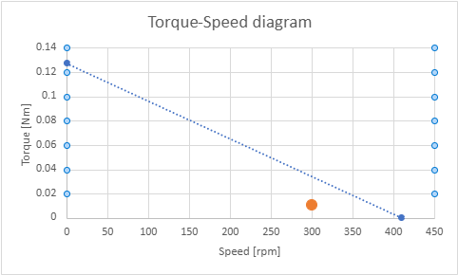

  - Show how motor voltage and current requirements were determined for your motor, and how these numbers correspond to the selected power electronics to be used in the system. Specify the chosen motor and power electronics parts to be used. -[DONE]Yanhao
Motor Voltage and Current Requirements and Corresponding Power Electronics.docx
